First Surname | Job Title

E **|**[name.surname@royalmail.com](mailto:name.surname@royalmail.com)

Royal Mail | 185 Farringdon Road | London | EC1A 1AA |

M **|**07XXX YYYYYY

[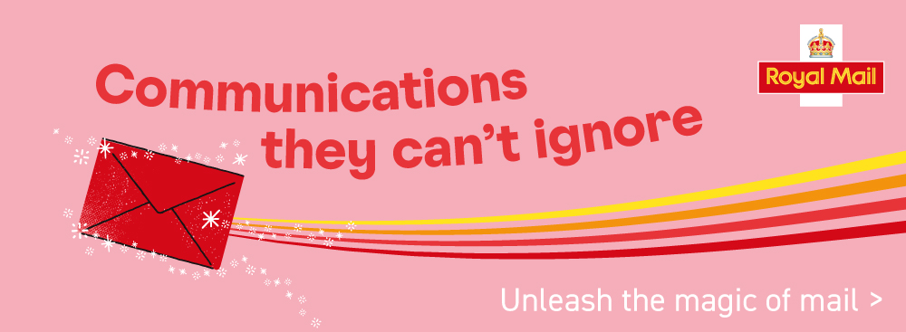](https://www.royalmail.com/business/marketing/direct-mail)